A project reportonMINI INVERTER 12V TO 220V

***Submitted by***

***M.Asad ur Rehman 2019-EE-389***

***M.Faizan Azam 2019-EE-381***

***M.Asad Tahir 2019-EE-383***

***Asim Bota 2019-EE-401***

***Section A Session-19***

**Instructor**

**Sir, Ali Raza**

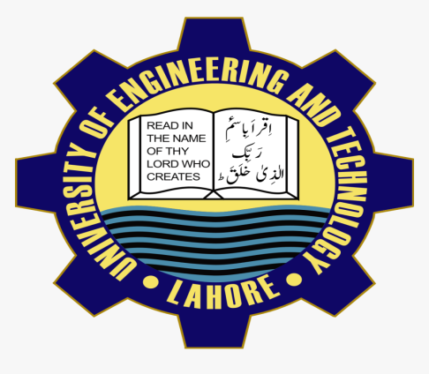

**ABSTRACT**

This power electronics device which converts DC power to AC power at required output voltage and frequency level is known as inverter. First of all, This project aims to produce a 12V DC power supply into 240V AC output, Using a transformer to step up the power. An inverter circuit is use to invert the DC energy into AC. This circuit needed to apply to the home electronics equipments. The circuit is to produce Sine wave output with low noise with applies up to 220-240 AC. This circuit is at the last stage of the report, we give some suggestion and recommendation  
About the future development and make it becomes more technology. In the future, we want target to commercialize and go through world Market for our project. As we know, every one of it project has their advantage And disadvantage.  
Beside of that, we have to reduce the entire disadvantage as much as Very well, we can to make it useful and easy to use for another people.

**Introduction of project**

we will be exposed to our research; on What  
kind of method have been used by us in order to get information and the Data for our project that is **Inverter single phase**. Some theoretical Background about inverter single phase is basically on how the it our self Operates and how it could possibly be done.

**Material Required**

* 12V DC supply
* 2-Transistor(2SC5200)
* Capacitors – 105microF
* 2-Resistor(1K)
* Transformer
* Diode(2A)
* Barro-board
* 4-Diode

**Circuit Diagram:**

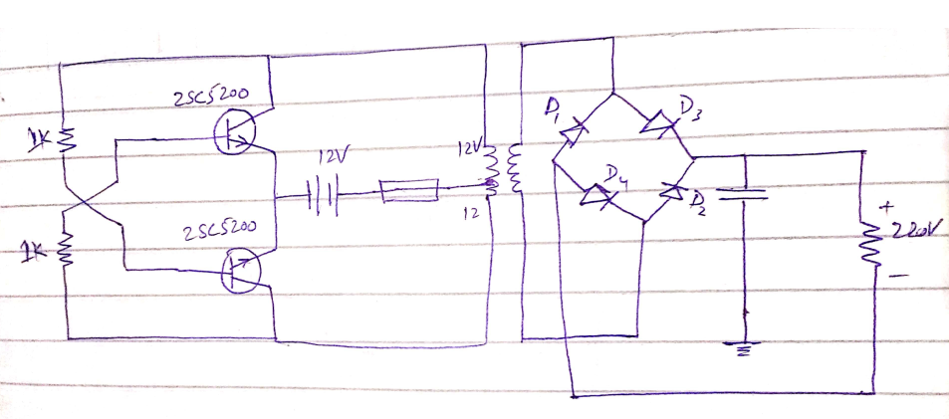

**Working:**

As from the circuit diagram, we use two transistor to make AC wave. On base portion of transistor we use 1k resistors because base current is too small need less current. We connect a two terminal on base and one is ground.

Take a battery and connect it with base and groung point.

Next we make a brigde with parallel capacitor for purification of sine signal .

Then we get 220 to 230 V. For testing we use led operate on 220.

**APPLICATIONS**

Power inverters are used today for many tasks like powering  
appliances in a car such as cell phones, radios and televisions. They also come  
in handy for consumers who own camping vehicles, boats and at constructing  
sites where an electric grid may not be as accessible to hook into. Inverters  
allow the user to provide AC power in areas where only batteries can be made  
available, allowing portability and freeing the user of long power cords.  
On the market today are two different types of power inverters, modified  
sine wave and pure sine wave generators. These inverters differ in their outs  
puts,providingvarying levels of efficiency and distortion that can  
affect electrons devices in different ways. A modified sine wave is similar to a  
square wave but instead has a “stepping” look to it that relates more in shape to a  
sine wave. The waveform is easy to produce because it is just the produce of the  
product of switching between 3 values at set frequencies, thereby leaving out the  
more complicated circuitry needed for a pure sine wave. The modified sine wave.  
The modified sine wave inverter provides a cheap and easy solution to powering  
devices that need AC power. It does have some drawbacks as not all devices work  
properly on a modified sine-wave, products such as computer and medical  
equipment are not resistance to the distortion of the signal and must be run off a  
pure sine wave powersource

**Results**

The first to create this project, we search all about already existing  
inverter systems in world. For example an inverter is an electrical device that converts direct current (DC) to alternating current (AC) the converted AC can be at any required voltage and frequency with the use of appropriate transformers, switching, and control circuits.

The major skill or we are learning about this project is inverter to  
generates the outputs supply and get the output voltage. What we get from thisis electronic soldering and wiring, single phase wiring circuits in connection,size cable use.

